# Assignment :

# Subject : ADVANCED DATA STRUCTURE

Bordekar Jayesh A.

M. Tech (ACDS)

PRN : 170101261005

**Date: 01/02/2018**

**University/Academic Institution: Sandip University Course Name: M.Tech ACDS**

**Batch Name: 2017-19 Module Name: Advanced Data Structures**

**Pre -Assignment: (All programs to be committed via git only)**

1. **Write a C++ program, which initializes a string variable to the content "The desire to learn should be stronger than the desire to live" and outputs the string to the disk file OUT.TXT. Include all the header files if required.**

***Program :***

**#include <stdio.h>**

**#include<iostream>**

**#include<fstream>**

**using namespace std;**

**int main()**

**{**

**ofstream myfile;**

**myfile.open ("out.txt");**

**myfile << "\n\n The desire to learn should be stronger than the desire to live\n";**

**myfile.close();**

**cout<<"\n\n Please check out.txt file .... !!! \n\n ";**

**return 0;**

**}**

***Output :***

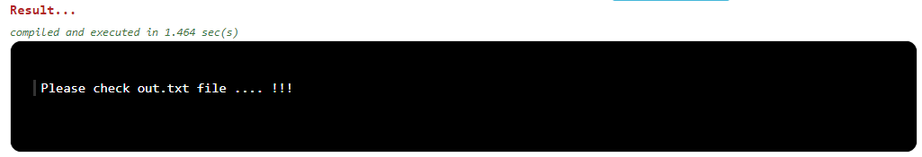

1. **Declare a structure to represent a complex number (a number having a real part and imaginary part). Write C++ functions to add, subtract, multiply and divide two complex numbers.**

***Program :***

**#include <stdio.h>**

**#include<iostream>**

**#include<math.h>**

**using namespace std;**

**struct complex**

**{**

**float rel;**

**float img;**

**}s1,s2;**

**int main()**

**{**

**float a,b;**

**cout<<"Enter Real and Imaginary Part of 1st Complex Number : ";**

**cin>>s1.rel>>s1.img;**

**cout<<"Enter Real and Imaginary Part of 2nd Complex Number : ";**

**cin>>s2.rel>>s2.img;**

***//Addition***

**a=(s1.rel)+(s2.rel);**

**b=(s1.img)+(s2.img);**

**cout<<"\n Addition : "<<"("<<a<<")"<<"+"<<"("<<b<<")"<<"i";**

***//Subtraction***

**a=(s1.rel)-(s2.rel);**

**b=(s1.img)-(s2.img);**

**cout<<"\n Subtraction : "<<"("<<a<<")"<<"+"<<"("<<b<<")"<<"i";**

***//Multiplication***

**a=((s1.rel)*(s2.rel))-((s1.img)*(s2.img));**

**b=((s1.rel)*(s2.img))+((s2.rel)*(s1.img));**

**cout<<"\n Multiplication : "<<"("<<a<<")"<<"+"<<"("<<b<<")"<<"i";**

***//Division***

**a=(((s1.rel)*(s2.rel))+((s1.img)*(s2.img)))/(pow(s2.rel,2)+pow(s2.img,2));**

**b=(((s2.rel)*(s1.img))-((s1.rel)*(s2.img)))/(pow(s2.rel,2)+pow(s2.img,2));**

**cout<<"\n Division : "<<"("<<a<<")"<<"+"<<"("<<b<<")"<<"i";**

**return 0;**

**}**

***Output :***

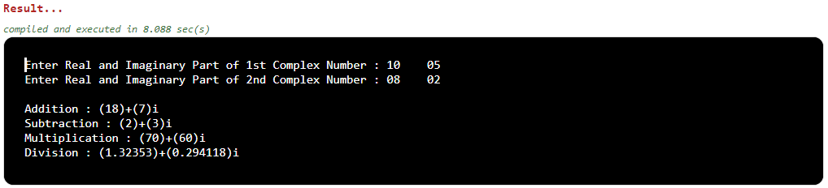

1. **Write a program in C++ to swap values of two variables using pointers.**

***Program :***

**#include<iostream>**

**using namespace std;**

**void swap(int *a, int *b){**

**int x = *a;**

**\*a = *b;**

**\*b = x;**

**}**

**int main()**

**{**

**int a = 0, b = 0;**

**cout<<"Enter the Value of a and b : ";**

**cin>>a>>b;**

**swap(&a, &b);**

**cout<<"After Swapping, \nThe Value of a = "<<a<<" \nThe Value of b = "<<b<<"";**

**return 0;**

**}**

**Output :~**

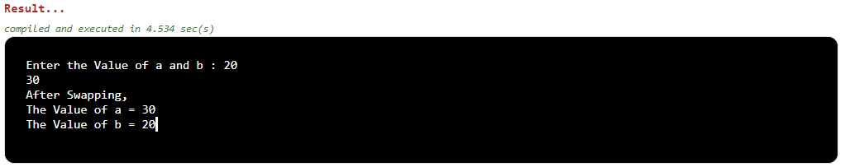

1. **Write the definition for a class called budget that has floating point data members income and tax. The class has the following member functions:  
   void show(float, float) to set the specified value in object  
   void display() to display income and tax**

**void calculate () to calculate tax on the basis of income (Rs 10000.0) and tax rate (18.0)**

***Program :***

**#include <stdio.h>**

**#include<iostream>**

**using namespace std;**

**class Budget**

**{**

**float INCOME,TAX;**

**public:**

**void show(float inc, float tax)**

**{**

**cout << "\n Enter the Total Income : \t";**

**cin >>INCOME;**

**cout << "\n Enter the Tax Rate on Income : \t";**

**cin >> TAX;**

**inc=INCOME;**

**tax=TAX;**

**}**

**void display()**

**{**

**cout<<"\n Total Income of Employee : "<<INCOME;**

**cout<<"\n Total Tax on Income: "<<TAX;**

**}**

**void calculate()**

**{**

**float TAX_VALUE;**

**TAX_VALUE=((INCOME*TAX)/100);**

**cout<<"\n Total Income Tax Value : "<<TAX_VALUE<<"\n";**

**}**

**};**

**int main()**

**{**

**Budget B;**

**B.show(20,30);**

**B.display();**

**B.calculate();**

**return 0;**

**}**

***Output :***

